UPDATED: 14/06/2016 (AH)

**Colour Calibration in Desktop Psychomorph**

1. Ensure that your imageset is complete
2. Convert all .tiff images to .png using Graphic Converter (.bmp would also be fine, but we’ve used .png for ocmate, just be sure you **DO NOT convert to .jpg** b/c image compression can alter color)

 (This is the graphic converter icon)

* 1. Use the “convert & modify” window (can select this from the file menubar option or use keyboard shortcut ^⌘M)
  2. Navigate to the folder that contains the .tif images in the “From:” bar on the left side
  3. Set your output directory for the .png images in the “To:” bar on the right side
  4. Make sure the Function option is set to “Convert” and the Destination Format is set to “PNG”

*\*\*\*Note: you can work directly from the facelab server or you can work on your desktop and copy the images back to the server when finished converting*

* 1. Select the images you want to convert and hit the GO button
  2. Copy images back to appropriate folder on the facelab server (if needed)

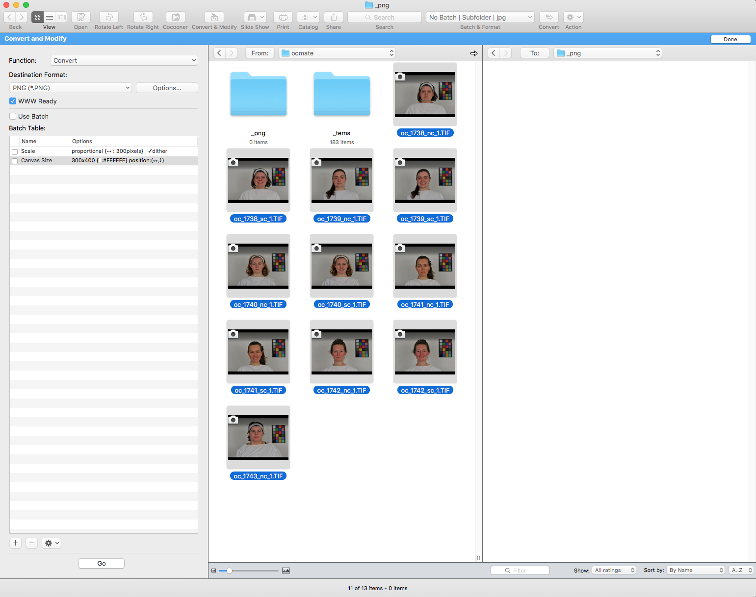

1. You will need to work from the DELL PC to do the color calibration
   1. Copy your png image files from the facelab server onto the desktop (don’t work from the facelab server for this part!)
   2. Also copy the color chart file that goes with the images, called a SpectrumFile: e.g., ‘chart_1.txt’[1] (GET THE CORRECT CHART VALUES FOR THE CHART USED AT THE TIME OF PHOTOGRAPHS FROM Facelab_Color_Charts_Lab_Values.xlsx”)
2. Make a text list of your images (this can be done in a text editor, new psychomorph, old Psychomorph…whatever!)
3. Open “New Psychomorph” on the desktop (launch.jnlp)
4. Make sure the color calibration plugin is loaded
   1. Go to Plugins, and make sure “ColourCalibrate.jar” shows up on the list
   2. If not, select the “Load Plugin” option, and select the ColourCalibrate.jar file from the desktop
5. Load first image of the sequence into the Transform window
6. Select View 🡪 View Rectangle, which will put a small red square in the top left corner of the image
7. Drag your cursor from the top left corner of the color chart and draw the rectangle so that it goes around the border of the color chart.
   1. Make sure the red line is within the black boundaries of the chart border
   2. It doesn’t need to be perfect, but the more precise you are, the less likely Psychomorph will glitch
8. Select Plugins 🡪 ColourCalibrate 🡪 Batch Calibrate Colour
9. Select Spectrum File from folders
10. TPS interpolation: Thin plate spline method Yes
11. Re-estimate colour for each image? Yes.
    1. If you select no each image will be calibrated to the delta-e values determined on the first image. Useful if not all images have a colour chart
12. Auto-detect colour chart? Yes. If no Psychomorph will assume the chart is in the exact same location on each image. Usually ‘yes’ is better here
13. Display target colours on grid? Yes
    1. This will put little color circles in each of the chart squares in the output image and is useful to identify color calibrated images generally, as well as helpful when you do the visual inspection step (below)
14. It will ask you to save a settings file. Just type “calib” and hit enter.
15. Specify the images you want it to batch calibrate by selecting your image_list.txt
16. Specify output directory for new images
    1. Create a new subfolder called “calibrated” to store the new images
17. Specify text to be appended to each image name as “_calibrated”
    1. If left blank images will have keep the original name
18. Once the batch processing has finished, you need to visually inspect ALL images at full size to make sure Psychomorph hasn’t “lost” the color chart and incorrectly calibrated the color
    1. Sometimes this will be very obvious (bright blue images, etc)

*****add in example image*****

* 1. Other times it’s very subtle

*****add in example image*****

1. Copy all calibrated images back to the appropriate folder on the facelab server

1. This file was created in our lab by measuring the colour chart with the spectrophotometer. It could also be created from the published values of each colour tile.